**Experiment: 1**

**Aim:** Write a program that perform the following output for n rows

**Software:** Dev C++

**Code:**

**#include<stdio.h>**

**int main()**

**{ int temp=1,n;**

**printf("Enter The Number Of Rows:-");**

**scanf("%d",&n);**

**for(int i=1;i<=n;i++)**

**{**

**for(int j=1;j<=i;j++)**

**{**

**printf("%d ",temp);**

**temp++;**

**}**

**printf("\n");**

**}**

**return 0;**

**}**

**Output:**

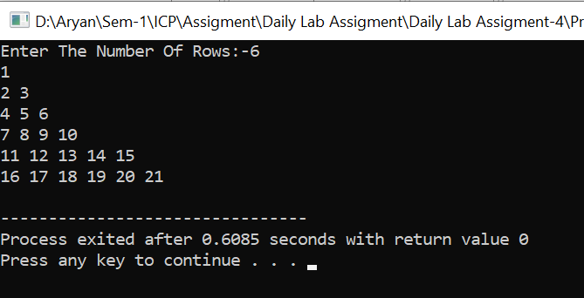

**Experiment: 2**

**Aim:** Print pattern like follow.

**Software:** Dev C++

**Code:**

**#include<stdio.h>**

**int main()**

**{for(int i=5;i>=1;i--)**

**{for(int j=i;j>=1;j--)**

**{printf("%d ",j);}**

**printf("\n");}**

**return 0;**

**}**

**Output:**

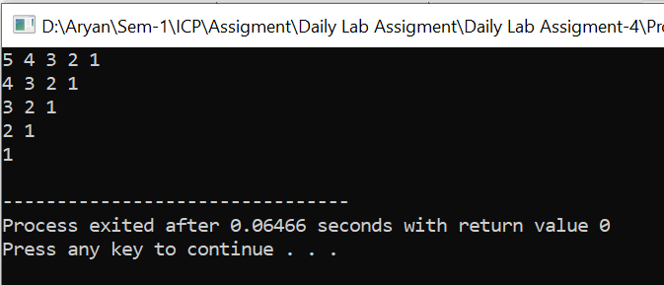

**Experiment: 3**

**Aim:** Compare while, do while and for loop through a program.

**Software:** Dev C++

**Code:-**

#include<stdio.h>

int main()

{int n,i=1;

printf("Enter The Number:-");

scanf("%d",&n);

while(i<=n){

printf("%d \n",i);

i++;}

printf("\n\n");

for(i=1;i<=n;i++){

printf("%d \n",i);}

printf("\n\n");

i=1;

do

{printf("%d \n",i);

i++;

}while(i<=n);

}

**Output:**

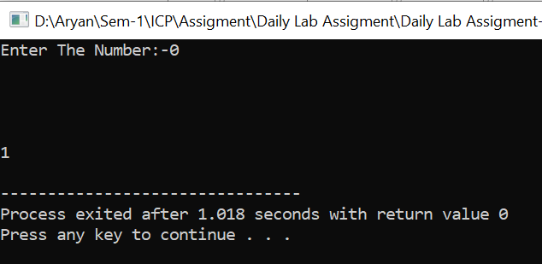

**Experiment: 4**

**Aim:**  Demonstrate Menu Driven program through switch case.

**Software:** Dev C++

**Code:-**

**#include<stdio.h>**

**int main()**

**{**

**char operation;**

**int a,b;**

**printf("Enter The Operation:-");**

**scanf("%c",&operation);**

**printf("Enter The Value Of a:-");**

**scanf("%d",&a);**

**printf("Enter The Value Of b:-");**

**scanf("%d",&b);**

**switch(operation)**

**{**

**case '+' :**

**{**

**printf("The Addition Is %d",a+b);**

**break;**

**}**

**case '-' :**

**{**

**printf("The Substraction Is %d",a-b);**

**break;**

**}**

**case '*' :**

**{**

**printf("The Multiplication Is %d",a*b);**

**break;**

**}**

**case '/' :**

**{**

**printf("The Multiplication Is %d",a/b);**

**break;**

**}**

**case '%' :**

**{**

**printf("The Modulo Is %d",a%b);**

**break;**

**}**

**default :**

**{**

**printf("Choose Valid Operation");**

**break;**

**}**

**}**

**}**

**Output:-**

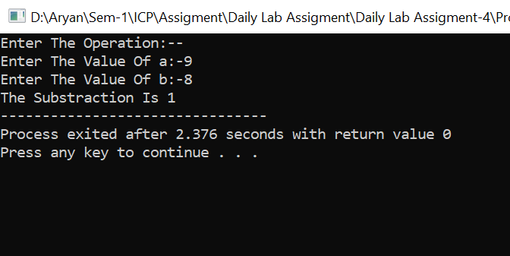

**Experiment: 5**

**Aim:-**  A company insures its drivers in the following cases:  
if the driver is married;  
• If the driver is unmarried, male, and above 30 years of age;  
• If the driver is unmarried, female, and above 25 years of age.  
In all other cases the driver is not insured. If the marital status, sex, and age of the  
driver are the inputs, write a program to determine whether the driver is to be insured  
or not.

**Software:-** Dev C++

**Code:-**

**#include<stdio.h>**

**int main()**

**{ char marriage_status,gender;**

**int age;**

**printf("Enter Your Marriage Status:-");**

**scanf("%c",&marriage_status);**

**fflush(stdin);**

**printf("Enter Your Gender:-");**

**scanf("%c",&gender);**

**fflush(stdin);**

**printf("Enter Your Age:-");**

**scanf("%d",&age);**

**if(marriage_status=='M' || marriage_status=='m'){**

**printf("Driver Is Insaured\n");}**

**else{**

**if((gender=='m' || gender=='M') && age>=30){**

**printf("Driver Is Insaured\n");**

**}**

**else if((gender=='f' || gender=='F') && age>=25){**

**printf("Driver Is Insaured\n");**

**}**

**else{**

**printf("Driver Is Not Insaured\n");**

**}**

**}**

**return 0;**

**}**

**Output:-**

